Customer Buying Patterns

Overview

This report sets out to answer the following questions: “**Do customers in different regions spend more per transaction? Which regions spend the most/least?”** and “**Is there a relationship between number of items purchased and amount spent?”** These questions were answered by conducting exploratory data analytics on the customer demographics dataset. Answering these questions are necessary to increase the revenue of eCommerce sales for Blackwell.

The dataset that Blackwell prepared involves nearly 80,000 entries of customer demographic data. There are five columns of data, with the “in-store” and “region” columns representing categorical features while the “age”, “items” and “amount” columns represent numeric features. The “in-store” column indicates whether or not purchases took place online or at an in-store location. The “region” column indicates four regions wherein purchases took place, which are North, South, East and West. The “age” column indicates the age of a customer, which ranges between 18 to 85. The “amount” column indicates the total amount of money spent given a purchase, which ranges between 0 and 3000. The “items” column indicates the number of items bought given a purchase, which ranges between 1 to 8. It is important to acknowledge that the “in-store” and “region” columns feature numbers, but these numbers are not amounts. Rather, they are numeric codes. For instance, in the “in-store” column, the number 0 indicates online purchases while the number 1 indicates in-store purchases. This same principle is applicable to the “region” column, where the breakdown is as follows: 1: North, 2: South, 3: East, 4: West.

Visualizations

The following section of this report will include visualizations and brief commentaries for said visualizations.

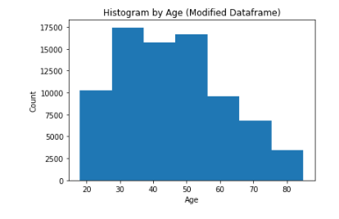

From the above graph, we see that most purchases were from individuals aged between 30 to about 55.

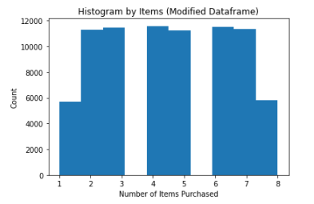

From the above graph, we see that most purchases involved item amounts between 2 and 7. More importantly, out of this range, no item amount is favored.

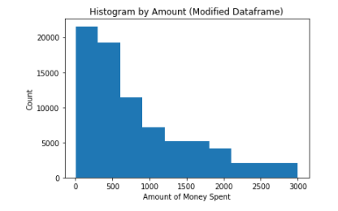

From the above graph, we see that most purchases involved transaction amounts between 0 and 500. That being said, the minimum purchase amount was 5.00.

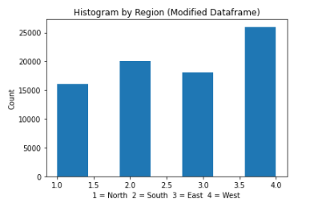

From the above graph, we see that most of the purchases took place in the West region.

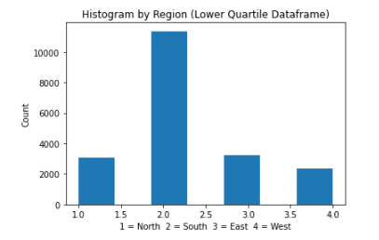

The above graph is based on a sub-selection of the modified dataset. This graph features data in which the value for the “amount” column was 285 or lower, which represents **customers that spent the least.** We clearly see that of this type of customer, an overwhelming majority of them take place in the South region. This means that Blackwell ***should not***focus on these customers for the purpose of maximizing revenue.

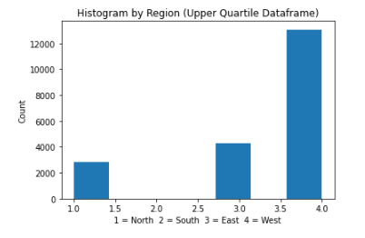

The above graph is based on a sub-selection of the modified dataset. This graph features data in which the value for the “amount” column was 1223 or higher, which represents **customers who spent the most**. We clearly see that of this type of customer, an overwhelming majority of them take place in the West region. This means that Blackwell ***should*** focus on these customers for the purpose of maximizing revenue.

Summary

Given the aforementioned visualizations and the full Jupyter Notebook file associated with this project, the answers to this project’s questions are as follows:

**It does clearly appear that different regions spend more per transaction.** In other words, the West region is more closely associated with high purchase amounts than any of the other regions.

**It does not clearly appear that there is a relationship between number of items purchased and amount spent**. In other words, it does not appear true that as number of items increase, so does the amount spent. The reverse can also be said. To reiterate further, the majority of overall purchases involves purchases that had item amounts between 2 and 7. Someone could have spent little and bought many items or have spent much and bought few items.

Given my analysis and the aforementioned conclusions, Blackwell should prioritize on appealing to their market(s) in the West region. This should not be done by trying to get customers to buy more items per purchase, as high item-amount purchases (6 items per purchase or more) are not clearly associated with greater spending. Having said that, it may be profitable for Blackwell to prioritize discounts and other cost-saving benefits for customers in the South region so as to spur more purchases in that region, even though customers in that region should not be prioritized directly.